Altitude and the distributional typology of language structure: ejectives and beyond

# 1.Introduction

In the context of the rise of cultural evolution, the present century has witnessed a surge of a strand of research which claims that human languages are adaptive to their respective environments broadly construed (cf. Lupyan and Dale 2016, Dediu et al. 2017, and Benítez-Burraco and Moran 2018 for review). The relevant environmental niches to which languages are theorized to be adaptive to are of different kinds: they may be of a sociolinguistic kind –as when languages with many L2 learners respond to this role by evolving structures that increases their learnability by adults (see e.g. Thurston 1987, Trudgill 2011, Bentz and Winter 2012.) They may be related to the medium in which language is transmitted: for instance, syntactically more complexly structured phrases and sentences tend to occur in the written rather than the oral medium, and more generally in languages with long traditions of writing and literacy (cf. Ong [1982] 2002). Finally, a particularly vibrant yet not entirely uncontroversial strand of research within this broader context pertains to the relationship between languages and the physical environment in which they are spoken (cf. e.g. Regier et al. 2016, Bentz et al. 2018, Urban 2018, to appear). That such research should be a topic that is in the news again would have seemed unlikely just a couple of decades ago, as it has been more or less banned from serious inquiry in the 20th century (cf. e.g. Sapir 1912). This is in large part in response to a preceding phase in which it blossomed in the 18th and 19th century: in the context of so-called “climatic theory” scholars of the times have theorized a more or less direct relationship between languages and their respective environments, arguing various theories that range from the absurd (such as the idea that the perceived “harsh” sound of Swiss German results from the goiters of the Swiss that in turn are caused by the hard Swiss water – Egenolff [1735] 1978) to the moderately more plausible but speculative (e.g. the idea that “[T]he serrated close way of Speaking of Northern Nations, may be owing to their Reluctance to open their Mouth wide in cold Air, which must make their Language abound in Consonants; whereas from a contrary Cause, the Inhabitants of warmer Climates opening their Mouths, must form a softer Language, abounding in Vowels” – Arbuthnot 1751: 153-154). In the 21st century, researchers have, often apparently unaware of their predecessors, begun to rediscover the relationship between language structure and physical environment as a serious topic of inquiry, and have posited dependencies between certain features of languages, in particular in phonology, that are sometimes surprisingly similar to what has been claimed in the 18th and 19th century (see Urban 2018 for extensive review of both phases in which such research flourished).

A facilitating role in the renaissance of the topic is played by the increasing availability of large linguistic databases that furnish comparative data across hundreds or even thousands of languages in a readily available format – though with the methodological danger of spurious correlations that arise only because of the vast possibilities of statistical hypothesis testing these databases allow (Roberts and Winters 2013; see now Roberts 2018 for an approach that mitigates that danger). Current approaches to linguistic typology are likewise conducive in paving the way towards the revival of this line of inquiry: typology has become less interested in the traditional goal of establishing linguistic types and (implicational) universals of language structure, but more in understanding the geographical distributions of typological features and their determinants (see Bickel 2007 for the programmatic statement). In the context of this reorientation, it is becoming increasingly clear that typological features, especially but not exclusively rare ones, are distributed unevenly across the globe and the task of linguistic typology in its current orientation is to explain why these are distributed the way they are.

# 2. Altitude and the distributional typology of language structure: ejectives and beyond

One prominent claim in the double context of the renewed interest in extralinguistic determinants on languages as adaptive systems –especially environmental influences on linguistic structure beyond the lexicon– and the reorientation of linguistic typology has been made by Everett (2013a). This study has raised considerable interest, but also controversy, especially because it makes the strong and explicit claim that there is a *direct* influence of the environment on language structure which is, as the author argues, not culturally mediated as is usually assumed in frameworks such as that of e.g. Regier et al. (2016) or Palmer et al. (2017).

The case pertains to ejective consonants. Relatively rare in the phonological systems of the languages of the world, ejective consonants are unlike the majority of consonants, produced using a non-pulmonic airflow mechanism. Rather, due to simultaneous closure of the glottis and a second closure in the buccal cavity (at either one of the usual places of articulation, though for reasons of articulatory effort most frequently at the velum) an amount of air is “trapped” in the part of the vocal tract between the two closures. Raising of the glottis due to muscular contraction, often visible from the exterior by a characteristic movement of the Adam’s Apple, causes the local air pressure in the relevant part of the vocal tract to rise. Upon sudden release of the closures, the air is released and the air pressure differential is rapidly equalized with a salient acoustic effect. To explore the distribution of ejective consonants, Everett (2013a) used data furnished by the *World Atlas of Language Structures* (WALS, Maddieson 2011, now updated as Maddieson 2013a), reducing the information offered by Maddieson to a binary variable (presence vs. absence of ejectives). The dataset includes information on 567 languages and is based on the earlier UCLA Phonological Segment Inventory Database (UPSID) that is underlying Maddieson (1984). Everett observed that ejectives tend to cluster in or near high-elevation regions of the world, including the Andes, the Caucasus, or the African Rift valley. Fig. 1. Shows the occurrence of ejective consonants in the most recent version of the PHOIBLE database (Moran and McCloy 2019), which includes the UPSID data but goes significantly beyond this seminal sample and all in all has data on phonological inventories from 2186 distinct languages.

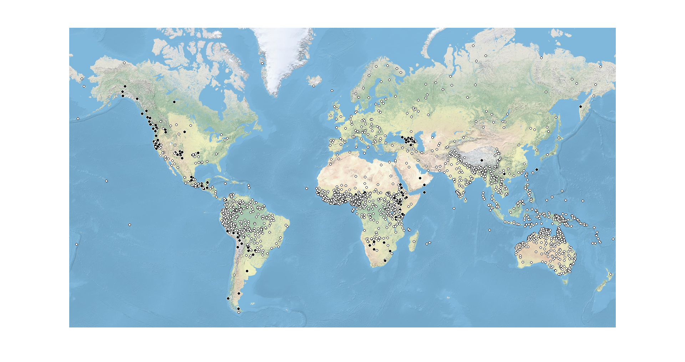

Fig. 1. Languages with ejective consonants in the PHOIBLE database.

Impressionistically, the distribution of ejectives according to PHOIBLE is quite similar as in WALS, with particularly salient hotspots in the North American Northwest and California (near the Rocky Mountains), Mesoamerica, the Andes, the Ethiopian highlands, and the Caucasus.

To assess whether the distribution of ejectives responds to elevation as the visual impression suggests, Everett (2013a) obtained abstract point coordinates (latitude and longitude) as provided by the WALS database. Points are mostly chosen such that they correspond to the center of the languages range, though for some languages idiosyncratic choices have been made (for instance, Russian appears to have been placed at the coordinates of Moscow). These Everett used, in turn, to obtain a measure for the elevation associated with each sampled language, more precisely, with each point coordinate that is representing a sampled language

Descriptively, the result was that the mean elevation (as extracted on the basis of WALS coordinates) for languages with ejectives was 955 masl and that without them was at 631 masl. To investigate further, Everett defined “high elevation zones”, i.e. regions “greater than 1500 m in altitude, plus land within 200 km of such a region of high altitude.”[1] The resulting 2 x 2 classification (presence vs. absence of ejective consonants and location of a language within such a “high elevation zone” vs. location outside) showed a statistically significant differences; later in the analysis, Everett (2013a) demonstrates that with ejectives that are outside the region are closer on average to such regions than those without.

For quite some time, it has been recognized that both genealogical and areal biases must be taken into account when assessing typological distributions. Everett (2013a) does address the possibility that the distribution of ejectives and the impression that they tend to occur at higher altitudes may be influenced by particular language families. However, he outrightly dismisses the idea that genealogical biases might confound the results by observing that in those regions where ejectives cluster together it is always several language families that are represented and contribute to the apparent pattern. Making the pioneering observation of large-scale areality in word order regularities, Dryer (1989) suggested that that a typological correlation can be considered genuine if it occurs in five of six so-called “macro areas” which have since then become a sort of widely applied quasi-standard in assessing areal effects in evaluations of typological distributions and correlations. Not situating his own analysis in this context explicitly, Everett offers a similar analysis by calculating the differences separately for Africa, Eurasia, South America and North America, noting that the expected differential occurs in Africa, Eurasia, and South America but not in North America (however, the difference is significant only for Africa as Everett 2013a’s Table 5 shows, but it does come out as significant throughout on the basis of a larger analysis informally offered in Everett 2013b; in both cases, no correction for multiple testing appears to have been carried out).

Everett (2013a) offers two different theories as to how the inclusion of ejective sounds in phonological inventories may be adaptive in high-altitude environments, without making a commitment whether either, both, or neither is really operative (cf. also Everett 2013b): one possible factor which Everett ponders is related to a tradition in linguistics that emphasizes the competing motivations, especially in phonology, between minimizing articulatory effort and maximizing expressive possibilities (e.g. Martinet 1952). Given that ambient air pressure is undoubtedly lower in high-altitude environments than it is closer to the sea level, the articulatory effort of ejectives, specifically the creation of the pressure differential that is necessary for their production, should be lower at high altitudes. This may be an incentive for speakers of languages in high-altitude environments to use this acoustically salient class of sounds. On the other hand, Everett hypothesizes, ejectives may also be adaptive in high-altitude environments because the non-pulmonic airflow that is involved in the production of ejectives may help to prevent desiccation, a significant problem in high-altitude environments due to generally lower air humidity (and the often limited availability of fresh water sources).

Evaluations of Everett’s (2013a) analysis and argument have been quick to follow the original publication, though in the form of blogposts rather than contributions to peer-reviewed outlets. These responses have focused on replication of the association rather than in addressing the plausibility of the proposed mechanisms, and conclusions were divergent: while Roberts (2013) reports approaching the proposal with considerable skepticism, to his surprise he in fact found support for the statistical association of ejectives with altitudes, whereas Hammarström (2013), on the basis of a different statistical approach, could not replicate a significant association. Given the conflicting conclusions and the informal manner in which they have been published the question is as of yet neither conclusively confirmed nor conclusively rejected.

As evaluation has been mainly focused on methodological issues and the significance of the association itself, it is natural that the examination of the proposed explanatory theories and the evaluation of these against possible alternatives have been put aside.

When working on the typology of American languages (results now published in Urban et al. 2019) one of us noted casually and impressionistically that ejectives in the languages of Middle and South America tend to co-occur with another type of relatively rare and articulatory costly sound, namely uvulars, on which the questionnaire used for the Urban et al. (2019) also solicited information for the sampled languages. Checking the American situation against large-scale phonological databases beyond the narrow situation in Middle and South America, it becomes clear that, in fact, the distribution of uvulars seems highly similar to that of ejectives. Fig. 2. plots the location of languages with uvular consonants in the PHOIBLE database, giving a visual impression of this apparent distributional overlap.

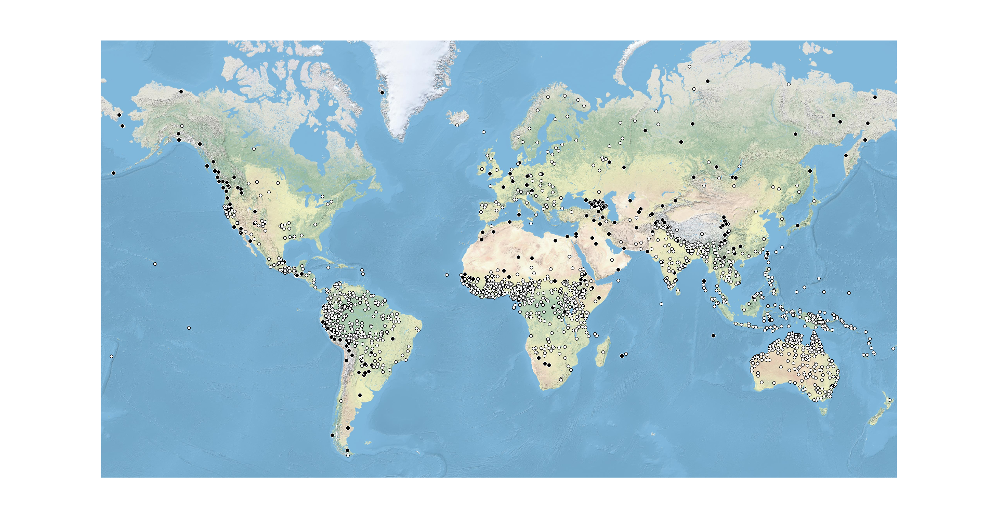Fig. 2. Languages with uvular consonants in the PHOIBLE database

In fact, on the basis of the initial visual impression one might be similarly inclined to suspect an elevation-dependent distribution of this class of sounds. The fit seems to be even “better” than that of ejectives, since “[t]he only major region of high elevation where languages with ejectives are absent is the large Tibetan plateau, along with adjacent regions of high altitude” (Everett 2013a), but uvulars actually are found prominently exactly also there (cf. further discussion in section 4).

The impressionistically similar distribution of uvulars in geographical space, with hotspots of occurrence in high-altitude mountain areas of different areas of the world, if genuine and robust, would also invite the search for hypotheses that could account for the distribution of both classes of sounds and their apparent overlap. Since the articulation of uvulars, like most other consonants but unlike ejectives, involves pulmonic airflow, the explanations pondered by Everett (2013a) for the special case of ejectives are unviable to explain a possible elevation-dependent distribution of uvulars in the languages of the world. However, if it can be corroborated, the similarities in distribution between both types of sounds, do suggest that some general factor is in play governing them.

Mountain environments with their challenging topography are commonly thought of as having the effect of isolating human communities and limiting communication between them; this, in turn, is thought to influence the structural profiles of languages spoken in high-elevation environments, which, in the absence of significant second language learning that would exert simplification pressures, are thought of as accumulating complex and more generally rare and hard to learn structures. This can happen either through the retention of such structures that are lost elsewhere or by their accumulation through diachronic change (cf. Urban to appear for review on language use and structure in mountain environments). Independently from Everett (2013a), Nichols (2013: 38) makes reference to precisely the classes of sounds of interest here when exemplifying this line of thought:

isolation favors (or at least does not disfavor) complexity, mountain geography favors isolation, and complexity of sound systems necessarily entails expansion along certain dimensions. Thus ejectives and uvulars can be found in mountain areas – not because harsh mountain geography deterministically causes language to add harsh consonant series (!), but because isolation favors complexity

What, however, can legitimately count as “complex” segments? When operationalized as in McWhorter (2001), who equates “complexity” for practical purposes with cross-linguistic rarity, then both classes of sounds qualify (though the question of how to precisely define “cross-linguistically rare” would remain). But also other possible manners of defining the controversial notion of complexity in language would lead to similar conclusions: articulatory effort is undoubtedly high for ejectives; however, a greater articulatory effort of uvulars vis-à-vis other pulmonic stops that has been suspected before (cf. e.g. Moulton 1983: 268) is now biomechanically also quantifiable precisely: in articulatory effort uvulars (voiced and in CV syllables) are only exceeded by retroflex consonants (Lindblom et al. 2011: 79; in fact, voicing is disproportionally more costly for back consonants, cf. Ohala [1997]2010: 666-667). Another possible piece of evidence for the marked status of uvulars is that, in situations of language death, where marked segments tend to merge with less marked ones in favor of the latter’s phonetic properties, uvular stops tend to merge with velars (Thomason 2015: 60-61).

Additional reason for thinking in this direction comes from Nikolaev and Grossman’s (2018) study on affricate-rich languages in Eurasia, whose distribution is strikingly similar to that of languages with ejectives and uvulars. All three tend to be found in mountain areas – affricate-rich languages especially in the the Caucasus, the Hindu Kush, and the eastern Himalayas. Relevantly, the Nikolaev and Grossman (2018: 574-576) note that particularly rich inventories of affricates are typically dependent upon the presence of retroflex affricates. Since retroflex consonants, as just seen, are the only ones that exceed uvulars in articulatory effort in Lindblom et al.’s (2011) study, and since affricate rich languages have much the same distribution as uvulars and ejectives, the distribution of affricate-rich languages in Eurasia described by Nikolaev and Grossman would likewise be consistent with an account in terms of sociolinguistic behavior that is shaped by topography and that, in turn, shapes languages distributions, but inconsistent with direct environmental influences on language structure.[2]

Under this hypothesis, then, the distribution of ejectives would turn out to be a special instance of a more general phenomenon that governs the distribution of (certain types of) complex segments in the languages of the world. Concomitantly, a theory that invokes the sociolinguistic dynamics of mountain areas would have greater explanatory power than Everett’s account by invoking a single principle that is capable of explaining both the distribution of cross-linguistically rare types of sounds that involve either pulmonic or non-pulmonic airflow. Such an account would be in line with the Boasian tradition, which assumes that the physical environment in which a language is spoken may shape the communicative needs and behavior of speakers, and if anything these, in turn, rather than the environment directly, shape the structure of languages (cf. Boas 1911 and Sapir 1912 for original statements and Regier et al. 2016 for a recent reappraisal in the context of the resurgence of research at the language-environment interface sketched in section 1). Thus, in contrast with Everett’s (2013a) reasoning, which explicitly argues for direct influence of environment on language structure, the influence of environment on language structure, if existent at all, would be at best indirect and, mediated through human behavior.

From this discussion, a twofold goal emerges for the present study:

First, by formally reassessing the proposal of an altitude-based distribution of ejective consonants in the languages of the world, we seek to shed further light on this proposal, which has remained controversial. At the same time, we offer several improvements in terms of the data used for the analysis and the procedures to arrive at them. Some of these have been pointed out as reactions to the original article paper (e.g. Hammarström 2013, who questioned the validity of using the WALS data as the basis of statistical analysis), others have been brought up in the context of discussions of other research on the relationship between language and environment (e.g Hammarström 2016 on the necessity to control for genealogical and areal dependencies in the data in the same analysis rather than separately, or Collins 2016, who emphasizes the potentially significant role of language contact in shaping segment distributions). Yet another methodological improvement is the move away from using point coordinates as more or less arbitrarily chosen abstract representations of a languages range is more in line with most recent more sophisticated research in a modern geolinguistics that takes into account the range of languages into analysis (e.g. Pacheco Coelho et al. 2019, Hua et al. 2019). Details of the analysis are described in the following section. By reassessing the validity of the association between ejectives and altitude through a different dataset and different analytical techniques, we also contribute to a recent plea for robustness and incremental approaches in the assessment of the adaptive potential of human language (Roberts 2018).

However, we also emphasize that our study is not meant as a mere critical revelation of Everett (2013) narrowly. By examining the distribution of uvular consonants in light of the same predictive parameter, altitude, in the same overarching analytical framework, the main goal of our article in fact is not that, but to tackle the underlying causes for the distribution of certain sound classes. Generally, research has focused in sophisticated assessments of the distributions of individual phonological features. While these give us a good indication of the degree to which the distribution of the linguistic features can be thought of as governed by properties of the surroundings, where there is still a long way to go is in coming up with linguistically and culturally plausible concrete pathways by which the environmental influences might actually find their way into language structure. At the same time, it is notable that analyses have for the most part focused on individual classes of segments or phonological properties such as sonority (Fought et al. 2004) or tone (Everett et al 2015, 2016a). As the preceding discussion of Everett’s (2013a) claim for an altitude-dependent distribution of ejectives shows, this runs the danger of not seeing broader patterns that might affect the distribution of several heterogeneous sound classes or phonological features – as is the case for ejectives and uvulars, for instance. However, the joint consideration of these might induce, indeed require, different and broader explanatory accounts, namely ones that are appropriate for explaining the distribution of all involved types of sounds. Thus, at the same time as reassessing the relationship between ejectives and consonants, we seek to discriminate between the original direct environmental explanation for the distribution of ejectives and an alternative one that is more general in nature, less direct, and based on sociolinguistic effects of geography on linguistic structure.

# 3. Data and coding

## 3.1. Phonological data

One of the aspects of Everett (2013a) which has been criticized by Hammarström (2013) is the use of the UPSID-based WALS data from Maddieson (2011), which, as Hammarström (2013) notes, has not been designed for statistical manipulation. Hammarström (2013) recommends instead using either the World Phonotactics Database (Donohue et al. 2013) or PHOIBLE, which has originally been made available in 2012 and is now updated in Moran and McCloy (2019). Indeed, in a rejoinder to criticisms, Everett (2013b) provides summary statistics on the elevation of isolates and other analysis on the basis of data from the World Phonotactics Database. Since this source has in the meantime become unavailable, for our analyses in the present paper we use phonological data from the PHOIBLE database. The current version of PHOBLE (Moran and McCloy 2019) features phonological inventories of 2,186 distinct languages. Some of these inventories were extracted from primary descriptions of the languages for the purposes of inclusion in PHOIBLE; however, the database also incorporates data from other, typically more regionally specialized, phonological inventory databases. Using PHOIBLE’s system of classifying segments in these inventories on the basis of distinctive features, we extracted the number of uvular and ejective segments in the inventories from the database) For uvulars, we have taken into account consonants of all manners of articulation (rather than, e.g., just stops), and for ejectives, we have taken into account all places of articulation. We have excluded segments of both types that were annotated as being marginal in the language from analysis. Later, we converted these numbers to a binary variable that merely registers the presence or absence of uvular and ejective consonants per language, following in this regard the original study on ejectives by Everett (2013a).

Given that PHOIBLE incorporates data from heterogeneous sources, the 2,186 PHOIBLE languages map onto a significantly larger number of 3,020 inventories from different sources. These sometimes provide divergent accounts on the phonological inventories of the described languages. Therefore, a measure to avoid the inclusion of a single language more than once in the analysis, which would occur by a direct analysis of the PHOIBLE data, is necessary. Where for a given language (as represented by the ISO 639-3 code) more than one inventory from different sources is available, we have selected one on the basis of the following hierarchy:

PH > GM > SAPHON > UZ > EA > ER > SPA > AA > RA > UPSID

After selection of datasets according to this procedure, sometimes what remained in the highest-ranked source are data from more than one dialect of a given language, without a standard variety indicated. Where these didn’t differ with regard to the presence vs. absence of uvulars and ejectives, handling such cases was unproblematic, and the first listed dialect was kept while all others were removed from the datasets. In cases where different dialects of a language for which no standard variety was indicated differed with regard to the presence or absence of ejectives, all datasets were retained. This was the case only five times, namely for Kawarrang-Ogh Undjan, Western Balochi, Portuguese, and North Junín Quechua. The datasets are distinguished by modifying glottocodes by an index (i.e. North Junín Quechua has the glottocode nort2980, and we distinguish the different datasets here as nort2980_01, nort2980_02, and nort2980_03).

## 3.2. Elevation data

Another point of criticism which Everett (2013a) has received pertained to the problematic use of point coordinates to represent the geographical location of a language. In response, Everett (2013b) has computed mean elevation of 100km and 500km ranges around dot coordinates to account or possible differences in slope and topography of the terrain surrounding the point coordinate representing the languages. Instead of relying on point coordinates, here, we do away entirely with reliance on more or less arbitrarily chosen point coordinates as the basis for obtaining information on the elevation of the region in which a language is spoken. Instead, …

## 3.3. Genealogical affiliations and areal breakdown

For modelling the effect of altitude on the distribution of ejective and uvular consonants while taking into account the genealogical structure of the world’s languages, we have relied on the Glottolog’s classification of the world’s languages (Hammarström et al. 2020), which tends to be conservative in accepting proposals for genealogical relations by insisting on documented evidence for form-meaning similarities that are explained in a least costly manner by inheritance from a common ancestor. The dataset underlying Glottolog assigns unique alphanumeric identifiers (“glottocodes”) to both languages and language families, but does not explicitly treat language isolates as singleton language families. For the purpose of our analysis, we have assigned these to pseudo-families called “isolate_1,” “isolate_2” etc. to reflect the fact that they, like language families, represent of genealogically independent lineages. Glottolog also retains some data for bookkeeping purposes, which are assigned to a pseudo-family with the glottocode “book1242”; we have removed these entries from the dataset, as Glottolog informs that for each such entry that it “has been retired and is featured here only for bookkeeping purposes. Either the entry has been replaced with one or more more accurate entries or it has been retired because it was based on a misunderstanding to begin with.”

While Glottolog thus provides a convenient and well-curated genealogical classification for controlling for inheritance, doing the same for contact-induced areality is more difficult generally and also for present purposes specifically. Standard off-the-shelf breakdowns such as that by Dryer (1989) that is also implemented in WALS, or its recent modification by Hammarström and Donohue (2014), are not ideal for present purposes as they divide the world into macroareas that are large enough to contain several salient high-altitude zones and/or hotspots in the distribution of ejectives and/or uvulars. For instance, the Eurasian macroarea as defined in these breakdowns would include the Alps, the Caucasus, the Hindu Kush, and the Himalayas. From a conceptual point of view, using this breakdown for present purposes would entail an unspoken expectation that these major mountain ranges should behave alike, or can at least be treated analytically as behaving alike with regard to the distribution of uvulars and ejectives. However, in fact, there is no robust reason to assume that, simply because they are all ubicated on the Eurasian landmass, this should be the case. We have therefore recognized the need for a more fine-grained breakdown in which high-elevation mountain regions are distributed more evenly across macroareas. In order to nevertheless retain a link with the extant literature, we have built on a breakdown that is based on Nichols’s (1992: 25-26) maximally differentiation of the world into areas that is also implemented in Urban (2012) for some analyses. Given that the PHOIBLE coverage is much denser than either Nichols’s (1992) and Urban’s (2012) samples, however, instructions and criteria to separate areas from one another geographically had to be amended. In addition, we did not make Nichols’s (1992) distinction between Western North America and Eastern North America here and also do not adopt Nichols’s (1992) Ancient Near East area for the obvious reason that no languages of the ancient Near East are included in PHOIBLE. Instead, we introduced a new area called “Western Asia” into the breakdown, which is not included in earlier analysis simply because were few or even none languages from this part of the world in the respective samples. Building on this work and modifying it to suit the purposes of the present research, we obtain a division of the world into eleven areas. Table 1 lists these, together with their conventional bounds from neighboring areas where these require specification in the second column. The third column provides impressionistic and non-systematic information on some of the major mountain areas within these areas (where existent).

|  |  |  |
| --- | --- | --- |
| Area | Comments | Major mountain areas |
| Europe | Includes the Caucasus and delimited from Northern Eurasia by its southern ranges and further north by the Ural mountains. Also includes Malta. | Alps, Caucasus |
| Northern Eurasia | Includes the Hindu Kush and the Himalayas; specifically, the Pakistani provinces of Gilgit and the Indian provinces of Jammu and Kashmir, Himachal Pradesh, Uttarakhand, Sikkim, Arunachal Pradesh as well Nepal and Bhutan as a whole. Beyond, South & Southeast Asia begins. In the Southeast, Northern Eurasia is delimited from South & Southeast Asia by the national boundary of China. Also includes Japan. | Urals, Hindu Kush, Himalayas |
| South & Southeast Asia | see above, includes islands to the east of New Guinea | “Zomia” (Scott 2009) |
| Africa | Delimited by the Isthmus of Suez and including Cape Verde, Madagascar, and the Mascarene Islands. | Ethiopian Highlands |
| North America | Bounded in the south by the US-Mexico border | Rocky Mountains |
| Middle America | Bounded in the north by the US-Mexico border and in the south by the Panama-Colombia border | Central Mexican Highlands |
| South America | Bounded in the north by the Panama-Colombia border | Andes |
| Oceania | Melanesia, Micronesia (including all Islands at the longitude of New Guinea and further east), and Polynesia |  |
| Australia |  |  |
| New Guinea | The island of New Guinea narrowly. Islands to the east were assigned to Oceania. | New Guinea highlands |
| Western Asia | The Middle East and those parts of Pakistan not assigned to Northern Eurasia |  |

Table 1. The 11 macroareas used in the present study to control for large-scale contact-induced areality.

When in doubt as to which macroarea a language should be assigned to, for instance in case of languages that are spoken both to the north and the south of the US-Mexico border, we have relied on the latitude and longitude as provided in Glottolog. This, of course, is ultimately arbitrary, but unlike using these coordinates *tout court*, only to a very small number of languages is affected. This procedure relieves us from making ad-hoc arbitrary decisions that might bias the outcome by referring to decisions that have been made earlier. As a final note, we have bypassed the difficult decision of assigning Aleut (spoken on the Aleutian islands) and Kalaallisut (spoken on Greenland) to any of the macroareas by leaving them unassigned (a problem Nichols 1992 dealt with by not including Eskimo-Aleut languages into the survey in the first place).

# 4. Analysis

## 4.1. Descriptive statistics

We begin the discussion of the data by providing some basic descriptive statistics. The mean altitude of languages with uvulars in the subset of the PHOIBLE data we analyze here is 1136.301 masl (median 623 masl) the mean of languages without uvulars is 590.1413 masl (median 306 masl). The mean of languages with ejectives is 1236.913 masl (median 1136 masl), the mean of languages without this class of sound is 606.0188 masl (median 304.5 masl). Thus, languages with both types of sounds are on average consistently spoken at higher altitudes that those that lack them.

We proceed by assessing mean evaluation of languages with uvulars and ejectives and those without separately by the macroareas defined in section 3.3. Table 2 provides the mean values for the eleven macroareas defined for this study, together with the number of languages contributing to each cell.

|  |  |  |  |  |  |  |  |  |
| --- | --- | --- | --- | --- | --- | --- | --- | --- |
| Macroarea | Mean elevation of languages with uvulars | *n* | Mean elevation of languages without uvulars | *n* | Mean elevation of languages with ejectives | *n* | Mean elevation of languages without ejectives | *n* |
| Europe | 872.9118 | 35 | 342.4667 | 81 | 1388 | 21 | 310.1573 | 95 |
| Africa | 755.3889 | 54 | 678.2531 | 653 | 1474.833 | 61 | 609 | 646 |
| New Guinea | 2184 | 1 | 645.0137 | 75 | n/a | 0 | 665.8108 | 76 |
| South & Southeast Asia | 722.8571 | 15 | 476.2844 | 219 | n/a | 0 | 491.6267 | 234 |
| South America | 1776.526 | 38 | 441.9898 | 296 | 1459.083 | 24 | 527.6645 | 310 |
| Northern Eurasia | 1755.964 | 59 | 1868.656 | 92 | 1303.75 | 4 | 1840.723 | 147 |
| North America | 627.1765 | 35 | 743.8364 | 56 | 749.6739 | 46 | 645.3488 | 45 |
| Australia | n/a | 0 | 190.6528 | 312 | n/a | 0 | 190.6528 | 312 |
| Middle America | 1034.6923 | 13 | 995.1892 | 37 | 1219.333 | 15 | 913.8 | 35 |
| Oceania | n/a | 0 | 300.3889 | 38 | n/a | 0 | 300.3889 | 38 |
| Western Asia | 875.2143 | 16 | 1340.6 | 5 | 1182 | 4 | 948.5333 | 17 |

Table 2. Mean elevation of languages with and without uvulars and ejectives for the eleven macroareas defined for this study an the number of languages in each group.

First, the table reveals some properties of the dataset that are worth bearing in mind: in some of the macroareas, Australia and Oceania, both uvulars and ejective consonants are completely absent (cf. also figs. 1 and 2). In addition, New Guinea and South & Southeast Asia host a very small number of languages with uvulars, and none with ejectives (cf. again figs. 1 and 2). It is interesting to note, incidentally, that the implicated macroregions are not randomly distributed but jointly identify a significant contiguous subpart of the world in which these sounds are rare or absent.

Where uvulars and ejectives occur more frequently, it is almost always the case that languages with uvulars and ejectives are spoken in regions with a a higher mean elevation than those that do not, although the different is minimal in some cases. The major anomaly is Northern Eurasia, where languages without uvulars and ejectives obtain higher mean values than those with them. Going against the general trend are also North America and Western Asia, though with regard to uvulars only.

By and large, descriptive summary statistics thus largely replicating the results obtained by Everett (2013a, 2013b) for ejectives. Furthermore, the fact that the generalization that languages with ejectives are on average spoken at higher altitudes than languages without them holds better than the analogous generalization (violated also in North America and Western Asia) might suggest that the relationship between ejectives and altitude is stronger than that between uvulars.

Obviously, however, it is necessary to analyze the situation in much more detail and from different angles to assess the robustness of this impression. For further analysis beyond descriptive statistics, here we combine a rigorous quantitative statistical and phylogenetic approach on the basis of the large-scale comparative data from PHOIBLE (as recently exemplified in the relevant line of research by Everett et al. 2015, 2016a and Roberts 2018) with a more qualitative intra-family analysis on the distribution and diachrony of relevant sound classes (as recently exemplified in the relevant line of research by Nikolaev and Grossman 2018), based on the conviction that such a combination of quantitative and qualitative perspectives allow for deeper insights into the analyzed phenomena than one of them alone.

## 4.2. Modelling the presence of ejectives and uvulars as a function of elevation

We first approach the question if the probability of observing languages with ejective and uvular consonants in the PHOIBLE data as modified according to the procedures described in 3.2. is higher at higher elevations by a global overall analysis of all available data. For this global analysis, we employ Bayesian logistic mixed effects regression as implemented in the R package brms (Bürkner 2017, 2018a, 2018b), which uses the Stan programming language’s interface with the R statistical programming environment (Stan Development Team 2018). We have included elevation as computed according to the procedure described in 3.2. as fixed effect after applying a log10-transformation. This is because of an extreme left skew in the distribution of the altitudes at which languages are spoken – as human populations are typically much denser at low altitudes (Cohen and Small 1998) so is apparently language density.

Hammarström (2016) emphasizes the importance in large-scale comparative analyses to control simultaneously for possible confounds due to genealogical “horizontal” dependencies (language relatedness) and areal “lateral” dependencies (due to prolonged coexistence in neighboring areas and interactions of speakers that led to contact-induced similarities) within the same analytic procedure. As Hammarström (2016) shows, when performing separate analysis to address their possible effects, can lead to conclusions that may be unwarranted. We have therefore included both genealogical affiliation and geographical location as captured by the eleven macroareas defined in 3.3. as random effects into our mixed model and fitted random intercepts for both variables. Since it is conceivable that, depending on area, contact patterns in different mountain regions (on which see the survey in Urban to appear) have differing effects on the distribution of uvulars and ejectives, we considered it advisable to also fit random slopes for the macroareas we are using to control for contact-induced areality. We did not include random slopes for the genealogical structure of the languages in the dataset because of the impossibility to fit these given the large number of small language families and isolates (see Jaeger 2011: 298-299 for discussion). However, since this data structure is also of potential concern for random intercepts, we later provide intra-family and intra-area assessments of variation in the presence of uvulars and ejectives to compare these with the results of the model. We have placed a weakly informative prior of SD = 2 on the fixed effect to be conservative and not constrain the model too tightly (even though with large amounts of data the prior should not affect the posterior distribution significantly, Vasishth et al. 2018: 149-150) and otherwise used default priors for the standard deviation of random effects and residual errors, which are constrained to positive values (cf. Vasishth et al. 2018: 150). We ran the model in four chains, with 6,000 warmups and 8,000 iterations each and the drift parameter delta set to .99.

R̂ values of 1 for each parameter, effective sample size estimates, and a visual inspection of the chains indicated that both models had converged, and comparisons of plots of observed data with posterior predictive samples showed that the models fit the data well. For each increase in altitude by 1 meter, the probability of observing a uvular increased by 3.6% (95% CI [2.6%, 5.5%]). However, the posterior probability of the effect being chance is relatively high (*p* = .23). In contrast, for each increase in altitude by 1 meter the probability of observing an ejective increased by 6.7% [3.4%, 8.9%], and the posterior probability of the effect being due to chance is relatively low (*p* = .017). In other words, the Bayesian mixed effect logistic regression supports an effect of altitude on ejectives more than it does support one on uvulars.

As alluded to, the large number of isolates and small language families of the world, which are also reflected in PHOIBLE, is a concern for fitting random effects structure. We have therefore, in addition to the Bayesian logistic mixed effects regression, performed least squares regressions on the means of elevation and uvular and ejective proportions within macroareas and within language families. As Bentz and Winter (2012: 8), who suggest this additional analysis in a similar situation, point out, this can be thought of as the analogues in language typology to a by-subjects and by-items treatment in a psycholinguistic experiment. For this additional analysis, we used the same macroareal breakdown described in section 3.3. that is also included in the main model. For the intra-family analysis, we focused on language families that were represented in the PHOIBLE database by 10 or more languages and in which either uvulars, ejectives, or both were actually attested: Afroasiatic, Arawakan, Athabaskan-Eyak-Tlingit, Atlantic-Congo, Austronesian, Cariban, Dravidian, Indo-European, Mande, Mayan, Mongolic, Nakh-Daghestanian, Otomanguean, Quechuan, Salishan, Sino- Ta-Ne-Omotic, Tibetan, Tai-Kadai, Tupian, Turkic, Uralic, and Uto-Aztecan. Intra-area and intra-family means are plotted against altitude means in fig. 3.

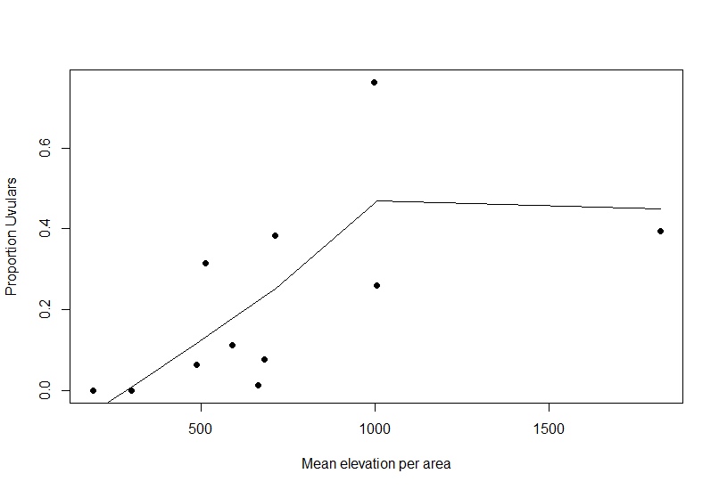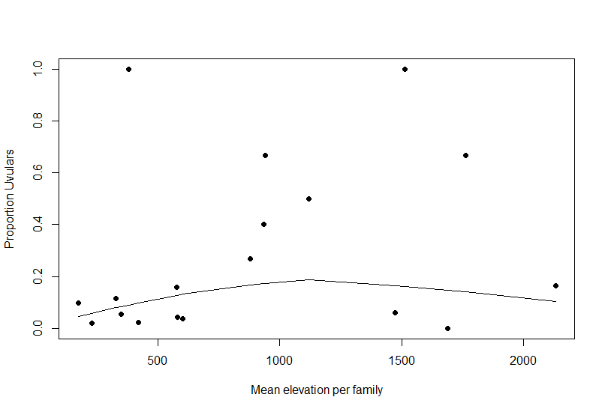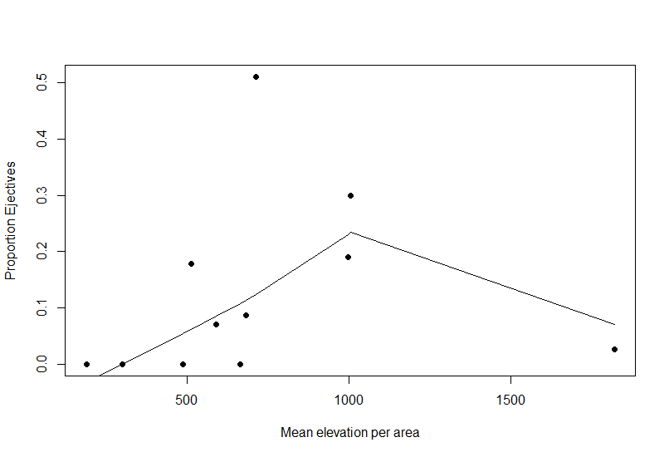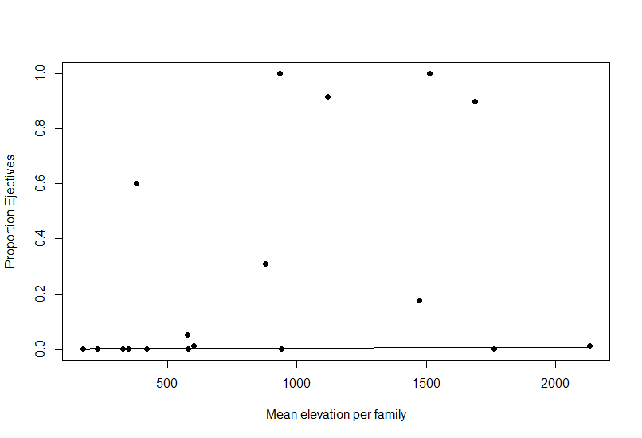

Fig. 3. Plots of intra-area and intra-family means for large language families with either uvulars or ejectives against altitude means; lines represent Lowess scatterplot smoothers.

Results of least square regressions were similar in that they have positive, but vanishingly small positive slopes. Moreover, with the only exception being the by-area treatment of uvulars which yielded a marginally significant results (p = 0.05829, Adjusted R2 0.2701), all analyses were insignificant and R2 values low, indicating that the fit to the data was poor. Generally, results for ejectives were not nota-bly better than for uvulars, casting doubts on whether the conclusion that the distribution of ejectives is governed more significantly by altitude is robust.

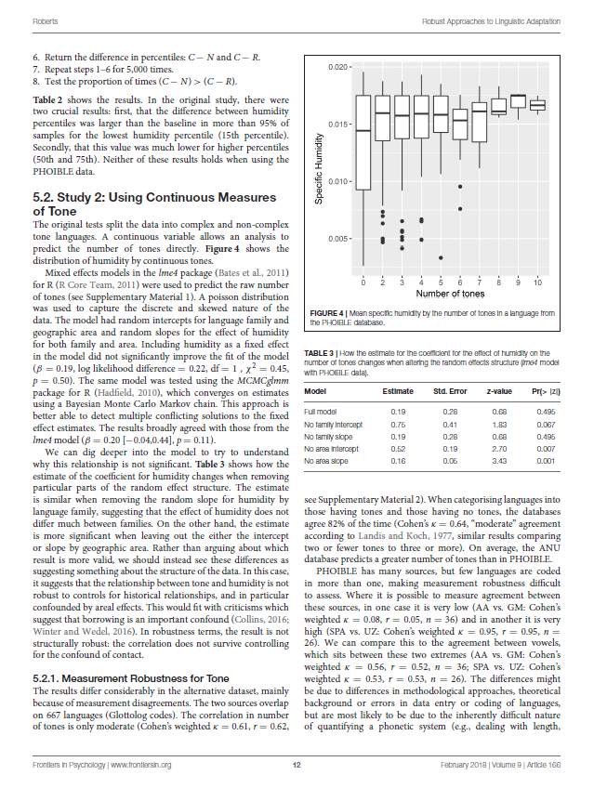

## 4.2. Exploring the evolution of ejectives and uvulars language families

When modelling the distributions as in 4.1. we factor out genealogical information in order to abstract away from the vicissitudes of the phylogenetic histories of individual families. As Cathcart (2018: 1) points out, this does not make maximal use of the data in that the evolutionary history of the traits of interest, and which may allow for important insights into the genesis of the synchronically observable patterns, are artificially discarded. For instance, to decide whether any of the two alternative accounts for the observed distributions that have been sketched in section 2 has merit, it is of significant interest whether ejectives and/or uvulars tend to *develop* within language families in high altitude environments or if they are *retained* there but tend to be lost elsewhere (i.e. whether they are recessive in the sense of Nichols 2003, as is argued by Nikolaev and Grossman 2018 for retroflex affricatives). These diachronic evolutionary perspectives are at the heart of recent research in distributional typology (Bickel 2011, 2015).

To assess the evolutionary dynamics of both classes of sounds within language families, we chose to look at two large and deep language families of Eurasia, Indo-European and Sino-Tibetan. Members of these families are spoken across a multitude of different ecozones and altitudes and, given that in both cases several millennia have passed since their breakup from a common ancestor, there should have been ample opportunities for environmental effects on the structures of daughter languages, if they exist, to play out.

Since we have reduced the PHOIBLE data to binary variables that simply register the presence vs. absence of uvulars and ejectives, we require a discrete variable model for phylogenetic reconstruction. We have used the phylogenies from Chang et al. (2015) for Indo-European and those from Zhang et al. (2019) for Sino-Tibetan. We have pruned these phylogenies to only retain those daughter languages that actually are included in our dataset. This results in a phylogeny with 58 (75) tips (languages) for Indo-European and 39 (72) for Sino-Tibetan. In order to increase the coverage, … To generate stochastic character maps (Nielsen, 2002; Huelsenbeck et. al, 2003; Revell, 2012) we used the make.simmap function from the R package phytools (Revell 2012) for an all rates different (ARD) model where q is set to empirical (maximum probability, full Bayesian MCMC) with 10 simulations on the ACQDIV phonology data.

As seen in fig. 4, ejectives are exceedingly rare in both language families. In the subset of Sino-Tibetan languages we can analyze here, they are only found in Khams Tibetan, and in the Indo-European languages we could analyze here, they are restricted to Ossetic and eastern Armenian. Uvular consonants are somewhat more frequent in both families and approximately in line with the cross-linguistic mean proportion in Europe and Northern Eurasia (ca, 30% and 39% respectively), but they are distributed widely across the phylogenies of both families. Tikkanen (2008: 254) describes a velar:uvular contrast as a “macroareal feature extending from North Africa over southwestern Asia to large parts of (especially middle and southern) Central Asia and –discontinuously– some parts of north Asia (northwestern and northeastern Siberia) and even Southeast Asia (Khmer).”

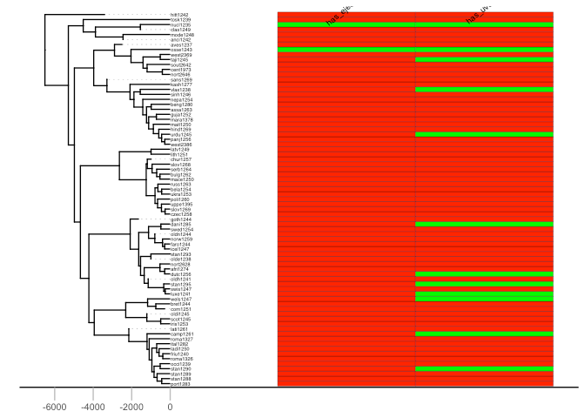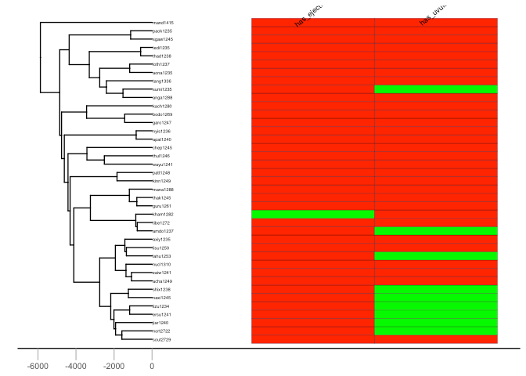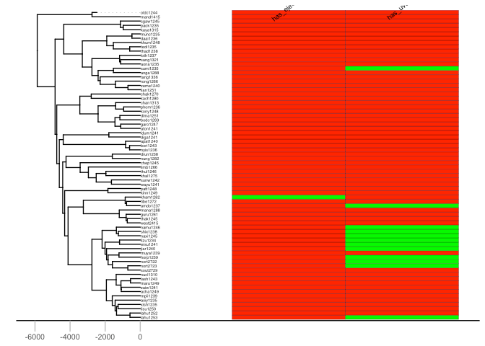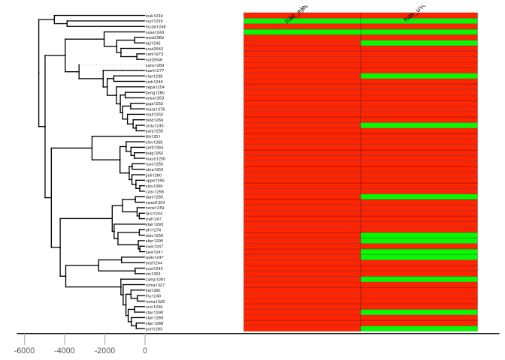

Fig. 4. Uvular and ejectives in Indo European (top) and Sino-Tibetan (bottom). Left hand plots represent the results of the analysis for the PHOIBLE data alone, right hand plots the results for the amended data by means of grammar mining.

As figures 5 and 6. show, neither trait is reconstructed far back in the respective phylogenies, though there is an interesting signal regarding uvulars in Sino-Tibetan which, on the basis of the phylogenetic reconstruction, appear to have been innovated at one point in a subgroup and then passed down to several present-day Sino-Tibetan languages.

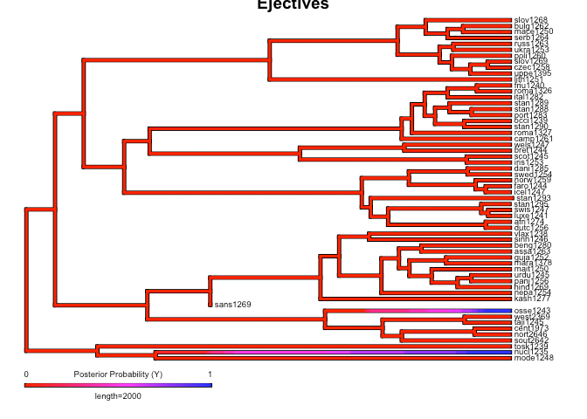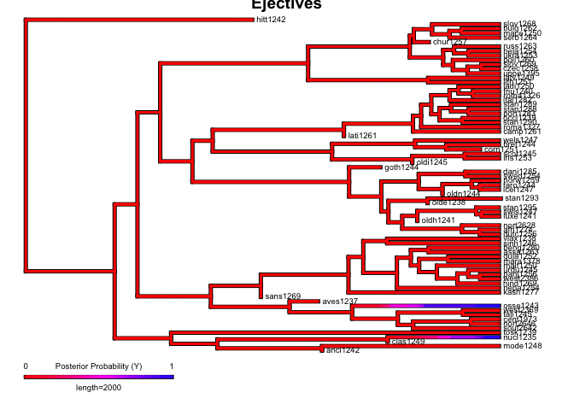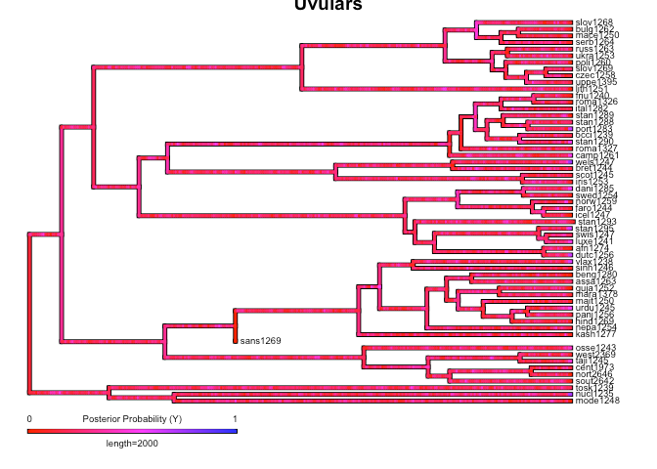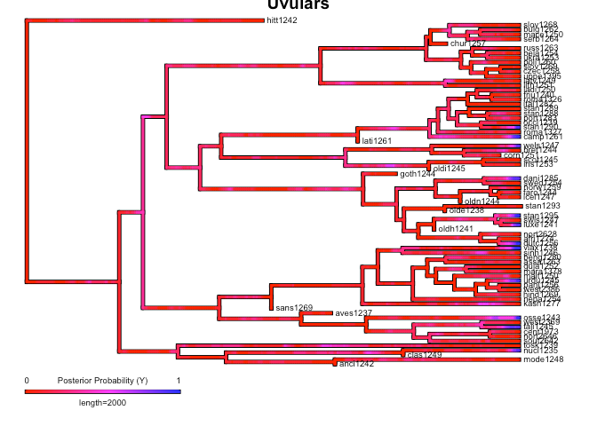

Fig. 5. Phylogenetic reconstruction of uvulars (top) and ejectives (bottom) in Indo-European. Left hand plots represent the results of the analysis for the PHOIBLE data alone, right hand plots the results for the amended data by means of grammar mining.

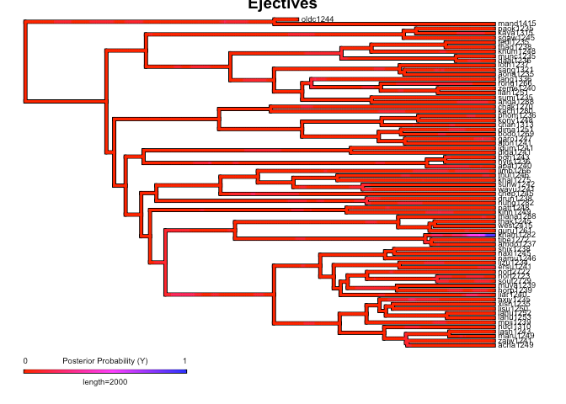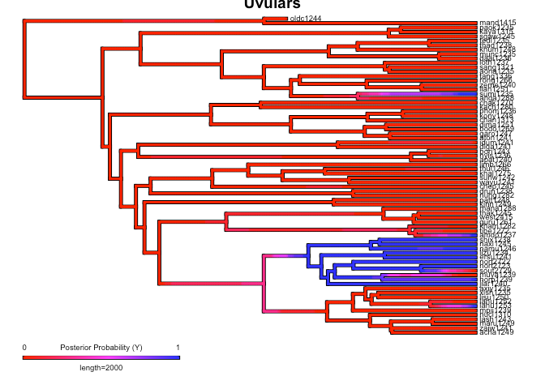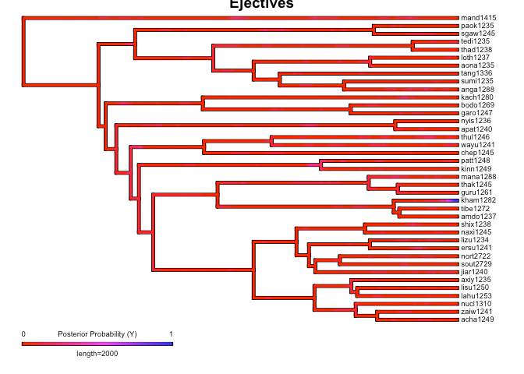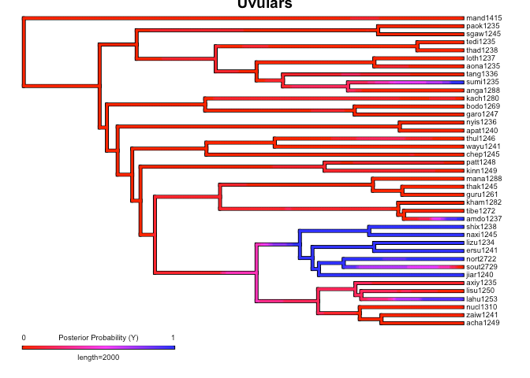

Fig. 6 Phylogenetic reconstruction of uvulars (top) and ejectives (bottom) in Sino-Tibetan. Left hand plots represent the results of the analysis for the PHOIBLE data alone, right hand plots the results for the amended data by means of grammar mining.

In the following, we proceed to provide an interpretation of the phylogenies, taking into account also the pertinent published literature on the diachrony of the involved languages and language families.

As far as ejectives in Indo-European languages are concerned, their genesis is fairly well understood: The evolution of ejectives in Ossetic is usually attributed to contact with neighboring Nakh-Daghestanian languages of the Caucasus, which are rich in ejectives. In Ossetic, direct loans from Nakh-Daghestanian account for the ejectives in most language’s lexical items (Job and Schäfer 2006), but there is also an regular sound change that gives rise to them and that likewise can plausibly be theorized to have been triggered by Nakh-Daghestanian influence (Thordarson 2009, Blevins 2017, Belyaev 2019). As far as we could ascertain, the majority opinion on ejectives in Armenian is that they are contact-induced, too, though there is an alternative theory that holds that they are instead directly inherited from proto-Indo-European, under the assumption of some version of glottalic theory. Interestingly, however, also proponents of this alternative view argue that contact actually is involved: instead of inducing the genesis of ejectives in Eastern Armenian as was the case for Ossetic, however, in this case it is rather argued that their proximity “favored the preservation of a feature which was already present” (Kortlandt 1985: 190). Whatever took place, it was at a relatively high altitude environment of the North Caucasus.

Since ejectives are not a significant factor in Sino-Tibetan languages, we move on to a discussion to uvulars, again starting with Indo-European. To begin, it is remarkable that among the Indo-European languages with this type of sound are exactly in Ossetic and Armenian, which, thus, do not only replicate one particular class of sounds of Caucasian languages, but rather have similar consonant inventories as Caucasian languages more generally, as Caucasian langauges are saliently characterized by rich systems of both ejectives and uvulars. Klimov (1965), Catford (1977) and Chiribka (2008) indeed noted that both ejectives and uvulars are areal features of the Caucasus; however, the wider proliferation of uvulars in Northern Eurasia has led Tuite (1999) to question the possibility of using these as area-defining features (cf. also Colarusso [1988]2016). Nevertheless, the uvular inventories of Caucasian languages is usually larger by far than those of other European languages (Chiribka 2008: 47-48). While the decision whether uvulars in the Caucasus can or cannot be considered a contact-induced areal feature is a matter for specialists to decide, here, we wish to note that also in the mountain of the Hindu Kush there are higher than expected frequencies of uvulars in Indo-European languages when compared with the cross-linguistic average (Liljegren 2017: 121). Contact with the prestigious Persian language, which has an uvular, is a relevant factor for the occurrence of uvulars in Indo-Aryan languages of the Hindu Kush, where they occur in Perso-Arabic loanwords as a “prestige pronunciation” (Liljegren 2017: 121) – indeed, in some but not all Indo-Aryan languages uvulars thus having a somewhat marginal status, and also in other Indo-Aryan languages, the contrast between velar and uvular stops is not always strongly established (Tikkanen 2008: 253). However, as is the case with ejectives in Ossetic, they are more deeply entrenched in the phonological inventories of languages from the northern part of the Hindu Kush region, where they are also found in native vocabulary (Liljegren 2017: 121). Tracing the history further back, the Persian uvular itself, while having internal sources, earlier received a major “boost” in frequency and functional load through the massive influx of Arabic loanwords (Bijankhan 2018). Here, we can trace aspects of the genesis of the areal-typological uvular belt from northwest Africa to Central Asia which Tikkanen (2008) describes to individual language contact events. Uvular consonants, especially rhotics, however, are also prominent in many languages of Europe. Again, the history of this phenomenon is contact-induced: uvular articulation of the rhotic originated in the Parisian dialect of French in the 17th century, and, as is the case for the Hindu Kush, spread as a prestige phenomenon from there first to the metropolitan centers of other countries (and thereby across language boundaries) and from there further down the line (Trudgill 1974). While, of course, the literature review is selective and there are cases, like Turkic and Mongolic, where uvulars arose apparently entirely from internal sources through the phonologization of an originally allophonic variation in the context of back vowels that still persists in some languages (Tikkanen 2008), the present-day distribution of uvulars is strongly influenced by areal factors, and language contact seems to have played a significant role in its genesis.[3]

Finally, we explore the apparent phylogenetic signal in the evolution of uvulars in Sino-Tibetan further, in particular with a view to assessing whether it may have something to do with the environment in which this took place.[4] In the PHOIBLE data (as modified for the purposes of this study as described in 3.1.), uvular consonants are found in various places of the Sino-Tibetan phylogeny, and we will not trace their history within the entire family here in full detail. In a nutshell, it seems that uvular sounds can be reconstructed to the proto-language, but merged with other sounds in different branches at various points of time; for instance, Old Chinese still retained uvulars, but modern Chinese lost them (Hill 2019: 32-33; 45). As far as the PHOIBLE data are concerned, however, there are two highland subgroups of Sino-Tibetan languages where they cluster together densely: these are Naic and Qiangic, which are hypothesized to form a common Na-Qiangic node together with Ersuic, where uvulars are also found (Michaud 2013: 13-14); however Michaud (2013) admits that speculation is involved and even Qiangic itself is not universally accepted (Chirkova 2012). Uvulars are indeed reconstructed for proto-Naish (a subgroup of Naic, Jacques and Michaud 2011: 492), and they have also been used to characterize Qiangic (Chirkova 2012: 137) and might reconstruct to proto-Qiangic under the assumption that the group is valid (Hill 2009: 124). However, as Chirkova (2012: 147) also notes, they are also found outside Qiangic, including “in a number of Tibetan dialects spoken in the zone of distribution of Qiangic languages,” i.e. Eastern Tibet and adjacent parts of Sichuan and Yunnan. The pruned phylogeny for our phylogenetic study does not reflect that well because the Tibetan evidence is mostly removed from the phylogenetic analysis as relevant Tibetan languages are not included in Zhang (2019) from which we derive our phylogeny. Hill (2009: 124) makes similar observations regarding the geographical distribution of uvulars in Tibetan: Noting that also other Sino-Tibetan languages in this region, as well as the Mongolian language Mongour, have uvulars, he says that “[t]he region can be regarded as a uvular prone Sprachbund.” Tentatively, he states that uvulars could have emerged in the Tibetan and Mongolian languages of the region due to a Qiangic substrate, given that the class of sounds seems to be more well-entrenched in this group of languages. In sum, while there is a phylogenetic signal in that several authors suggest the reconstructability of uvulars to low-level ancestors of local Sino-Tibetan subgroups, at least equally prominently the pattern of contact-induced emergence of uvulars that we have observed repeatedly elsewhere resurfaces –albeit here, as Hill (2009) suggests, possibly by a sub- rather than superstratum effect.

Now, even though it seems clear for at least some cases surveyed that contact was the main driver for the evolution of ejectives and uvulars, could this perhaps be only the proximate reason and the ultimate reason why they were replicated through contact be an adaptation to high-altitude environments such as those of the northern Caucasus and Eastern Tibet through language contact effects? As observed by Urban (2018), the extant literature is often Janus-faced when it comes to this question.Where clear evidence for contact as the factor that generated the spread of phonological phenomena across language and language family borders, this is swiftly integrated into an account based on adaptation to environmental conditions by stating that relevant features may have spread through contact precisely because they are adaptive (e.g. Everett et al. 2016b: 86 in response to Collins 2016). However, it is well to note that Eastern Tibet, where some amount of convergence regarding uvulars seems to have taken place, is notably lower in elevation than Western Tibet and has a markedly different climate and vegetation. One would accordingly have expected that convergence would rather take place at the highest altitudes if altitude were the relevant factor – note, however, that the language dynamics of altiplanos such as the Tibetan Plateau are usually different from mountain areas with a central crest (Nichols 2015) so that the account that operates with the assumption that higher altitude induces sociolinguistic isolation does not necessarily apply straightforwardly for these. More generally, we observed the spread of uvulars at least at both high and low altitudes (i.e. in Europe), which is another reason to prefer to not add another explanatory layer behind the contact-induced account (cf. Hammarström 2013 for similar reasoning).

In sum, for those cases of spread of uvular and ejectives spread it turned out that contact, rather than sociolinguistic isolation, seemed to be a decisive factor.

# 5. Discussion

In this contribution, we have examined the cross-linguistic distribution of two classes of sounds, ejectives and uvulars, and have sought to establish to what extent this distribution is predicted by environmental factors, concretely, the altitude of the area in which these languages are spoken.

The analyses were carried out in light of two competing hypotheses that may account for that distribution: one, due to Everett (2013a), that invokes the adaptive value of ejectives in high-altitude environments because of the reduced articulatory effort of these sounds and/or the advantage in preventing desiccation in the low ambient humidity. The other, alluded to by Nichols (2012), rather, operates on considerations having to do with sociolinguistic typology; specifically, sociolinguistic isolation (manifested e.g. by intra-community use of languages at the highest altitudes and little L2 learning) should lead to the accruing of complex and marked language structures generally, a characterization that applies to both ejectives and uvulars.

Our analyses over significant improvements in terms of the primary data: we use the large PHOIBLE database to follow up on previous work in this regard by Everett (2013a, b) and a metric for altitude that avoids the simplicistic use of more or less arbitrarily chosen point coordinates.

Roberts (2018) argues for a robustness approach to the analysis of adaptivity of languages to their environment. This entails, among other things, the test of pertinent hypotheses against different datasets and the use of different statistical methods to assess if, or to what extent, analyses converge on similar results. Rather than a single outcome, this yields a “space of results” that jointly give an idea of the robustness of the tested hypothesis, which should ideally not be developed ad hoc but be based on already existing theorizing or experimental evidence. Another hallmark of this approach is its reliance on incremental research: by testing already developed hypotheses on a different dataset against which they have not yet been evaluated, and by systematically comparing it with a conceptually different alternative that was not yet been evaluated statistically, our contribution fits squarely within this approach.

On this basis, a Bayesian mixed effects logistic regression showed that altitude has a larger effect on the probability of finding ejective consonants in a language than it does on uvulars, though by-area and by-family treatments did not allow to replicate the overall stronger effect of altitude on the posterior probability of the mixed model. Given this result, we have modelled the phylogenetic evolution of both classes of sounds in two large families of Eurasia, Indo-European and Sino-Tibetan, and have couched the interpretation of the results of the phylogenetic analysis in a selective qualitative survey of the pertinent literature. This survey suggested a strong role of language contact in the evolution of ejectives in Indo-European and of uvulars in both Indo-European and Sino-Tibetan. This is a situation that is at odds with the scenario that would be predicted by the alternative explanation for the distribution which, instead of arguing for adaptiveness of linguistic structure to environmental givens, would consider elevation as a proxy to sociolinguistic isolation. Both ejectives and uvulars seem to be prone to spread across language boundaries in language contact situations. Maddieson (2013b) notes similar behavior for clicks and labiovelars: “the evolution or adoption of sounds of these two classes in the sound system of a language is strongly influenced by hearing these sounds in other languages spoken in the same area” and the same thus, seems to be true for the two classes of segments which we investigate here. Together with the weak predictive power of altitude on the distribution of uvulars in the Bayesian modelling, this result leads to increased doubts regarding the sociolinguistic isolation account, at least in the rather simplistic manner in which it is presently operationalized. But also ejectives have been shown to figure prominently as the targets of replication in contact situation – analogously to the case of Ossetic and, more controversially, Eastern Armenian, they are likely to have been transferred from Aymaran to Quechuan languages in southern Peru and Bolivia in a situation of intense language contact. This is not in principle incompatible with the idea that ejectives are adaptive in high-altitude environments as they may spread in language contact precisely because of their adaptive value. However, as we have noted, before accepting this, it would be necessary to specify the relationship between language contact and adaptiveness in the theoretical framework, as this relationship often remains blurry and ambigous in extant work.[5]

A final observation that remains to be reiterated is the striking co-occurrence of both classes of sounds which, in fact, was one of the motivating factors for us to consider sociolinguistic isolation as a possible alternative explanation that would account for the distribution of ejectives, but also other types of rare and articulatorily costly segments in the first place. In the case of Ossetic we have seen that this language has not simply evolved ejectives under Nakh-Daghestanian influence but in fact the same characteristic combination of ejectives and uvulars that is found in Nakh-Daghestanian and Caucasian languages generally. These cases are representative of a more common cross-linguistic pattern. PHOIBLE contains data from 248 different language families (including isolates as singleton families). Of these, only 68 (ca. 28%) feature uvular consonants, and only 65 (ca. 26%) ejective consonants, highlighting once more the relative rarity of both classes. There is no logical necessity that both classes of sounds should co-occur in the same languages and language families. However, the distribution of the sounds is strikingly correlated, with a Jaccard similarity coefficient of approximately .41. Given the overall frequency of language families with the two classes of sounds, this is extremely unlikely the result of chance (p < .0000000001).

This suggests that there actually *may* be common underlying conditioning factors that governs the distributional typology of both classes of sounds and on which it is predicated, a suggestion that is also fueled by the striking absence or exceeding rarity of both classes of sounds in certain regions of the world such as New Guinea and Australia. What these factors is, and in what terms (typological, sociolinguistic, diachronic, or a combination of these or more angles) they could be described, is an open question. Given the intricate entanglement of linguistic behavior, socioeconomic organization, environment and its topography and the cumulative effect these have on language history and evolution, it might well be the interaction of several which, nevertheless, yields a striking clustering of ejectives and altitudes often in the same languages and language families. If elevation, either directly though adaptiveness or indirectly as conducive to sociolinguistic isolation has a (limited) role to play remains for further research to determine.

# References

Arbuthnot, John. 1751. An essay concerning the effects of air on human bodies. London: J. and R. Tonson and S. Draper.

Belyaev, Oleg. 2019. Contact influences in Ossetic. In: Anthony P. Grant (ed.): The Oxford Handbook

of Language Contact, 467-493. New York: Oxford University Press.

Benítez-Burraco, Antonio, and Steven Moran. 2018. Editorial: the adaptive value of languages: non-

linguistic causes of language diversity. In: Antonio Benítez-Burraco and Steven Moran (eds.): The adaptive value of languages: non-linguistic causes of language diversity. Frontiers in Psychology (Special Issue). Doi: <https://doi.org/10.3389/fpsyg.2018.01827>

Bentz, Christian, and Bodo Winter. 2013. Languages with more second language learners tend to lose

nominal case. Language Dynamics and Change 3 (1): 1-27.

Bentz, Christian, Dan Dediu, Annemarie Verkerk and Gerhard Jäger. 2018. The evolution of language

families is shaped by the environment beyond neutral drift. Nature Human Behaviour 2, 816-821.

Bickel, Balthasar. 2007. Typology in the 21st century: major current developments. Linguistic Typology

11 (1): 239-251.

Bickel, Balthasar. 2011. Statistical modeling of language universals. Linguistic Typology 15 (2): 401-

414.

Bickel, Balthasar. 2015. Distributional typology: statistical inquiries into the dynamics of linguistic

diversity. In: Bernd Heine and Heiko Narrog (eds.): The Oxford Handbook of Linguistic Analysis, 2nd edition, 901-923. Oxford: Oxford University Press.

Blevins, Juliette. 2017. Areal sound patterns: from perceptual magnets to stone soup. In: Raymond

Hickey (ed.): The Cambridge Handbook of Areal Linguistics, 88-121. Cambridge: Cambridge University Press.

Boas Franz. 1911. Introduction. In: Franz Boas (ed.): Handbook of American Indian Languages, vol.1,

1-83. Washington: Government Printing Office.

Bijankhan, Mahmood. 2018. Phonology. In: Anousha Sedighi and Pouneh Shabani-Jadidi (eds.): The

Oxford Handbook of Persian Linguistics, 111-141. Oxford: Oxford University Press.

Bürkner, Paul Christian. 2017. brms: AnRPackage for Bayesian Multilevel ModelsUsingStan. Journal of

Statistical Software 80 (1). Doi: [10.18637/jss.v080.i01](http://dx.doi.org/10.18637/jss.v080.i01)

Bürkner, Paul Christian. 2018a. Advanced Bayesian Multilevel Modeling with the R Package brms. The

R Journal 10 (1): 395-411.

Bürkner, Paul Christian. 2018b. brms: Bayesian Regression Models using 'Stan'. R package version

2.13.0.

Catford, J. C. 1977. Mountain of tongues: The languages of the Caucasus. Annual Reviews in

Anthropology 6: 283-314.

Cathcart, Chundra Aroor. 2018. Modeling linguistic evolution: a look under the hood. Linguistics

Vanguard 1: 20170043.

Chang, Will, Chundra Cathcart, David Hall, and Andrew Garrett. 2015. Ancestry-constrained

phylogenetic analysis supports the Indo-European steppe hypothesis. Language 91 (1): 194-244.

Chiribka, Viacheslav A. 2008. The problem of the Caucasian sprachbund. In: Pieter Muysken (ed.):

From linguistic areas to areal linguistics, 25-94. Amsterdam/Philadelphia: John Benjamins.

Chirkova, Katia. 2012. The Qiangic subgroup from an areal perspective: a case study of languages of

Muli. Language and Linguistics 13 (1): 133-170.

Colarusso, John. [1988]2016. The Northwest Caucasian languages: a phonological survey.

Abingdon/New York: Routledge.

Cohen, Joel E., and Christopher Small. 1998. Hypsographic demography: The distribution of human

population by altitude. Proceedings of the National Academy of Sciences of the United States of America 95 (24): 14009-14014.

Collins, Jeremy. 2016. Commentary: The role of language contact in creating correlations between humidity and tone. Journal of Language Evolution 1 (1): 46–52.

Dediu, Dan, Rick Janssen, and Scott R. Moisik. 2017. Language is not isolated from its wider

environment: vocal tract influences on the evolution of speech and language. Language & Communication 54: 9-20.

Donohue, Mark, Rebecca, Hetherington, James McElvenny, and Victoria Dawson. 2013. World phonotactics database. Canberra: Department of Linguistics, Australian National University.

Dryer, Matthew S. 1989. Large linguistic areas and language sampling. Studies in Language 13 (2):

257-292.

Egenolff, M. Joh. Aug. [1735]1978. M. Joh. Aug. Egenolffs Historie der teutschen Sprache. Erster

Theil. Andere Auflage, mit einer neuen Vorrede und Register vermehret. Leipzig: Zentralantiquariat der Deutschen Demokratischen Republik.

Everett, Caleb. 2013a. Evidence for direct geographic influences on linguistic sounds: the case of

ejectives. PLOS ONE, 8(6), e65275. <https://doi.org/10.1371/journal.pone.0065275>

Everett, Caleb 2013b. Into thin air: a return to ejectives at high altitude. LingBuzz.

https://ling.auf.net/lingbuzz/001944

Everett, Caleb, Damián E. Blasi, and Seán G. Roberts. 2015. Climate, vocal folds, and tonal languages:

Connecting the physiological and geographic dots. Proceedings of the National Academy of Sciences of the United States of America 112 (5): 1322–1327.

Everett, Caleb, Damián E. Blasi, and Seán G. Roberts. 2016a. Language evolution and climate: The

case of desiccation and tone. Journal of Language Evolution 1 (1): 33–46.

Everett, Caleb, Damián E. Blasi, and Seán G. Roberts. 2016b. Response: climate and language: has the

discourse shifted? Journal of Language Evolution 1 (1): 83-87.

Fought, John G., Robert L. Munroe, Carmen R. Fought, and Erin M. Good. 2004. Sonority and climate

in a world sample of languages: findings and prospects. Cross-Cultural Research 38 (1): 27–51.

Grawunder, Sven. 2017. The Caucasus. In: Raymond Hickey (ed.): The Cambridge Handbook of Areal

Linguistics, 356-395. Cambridge: Cambridge University Press.

Hammarström, Harald. 2013. C. Everett's ejectives/altitude correlation is not significant.

Diversity Linguistics Comment. <https://dlc.hypotheses.org/491>

Hammarström, Harald. 2016. Commentary: there is no demonstrable effect of desiccation. Journal of

Language Evolution 1 (1): 65-69.

Hammarström, Harald, and Mark Donohue. 2014. Some principles on the use of macroareas in

typological comparson. Language Dynamics and Change 4 (1): 167-187.

Hammarström, Harald, Robert Forkel, Martin Haspelmath, and Sebastian Bank. 2020. Glottolog 4.2.1.

Jena: Max Planck Institute for the Science of Human History. Online: https://glottolog.org/

Hill, Nathan W. 2009. Tibetan < <ḥ-> as a plain initial and its place in Old Tibetan phonology.

Linguistics of the Tibeto-Burman area 32 (1): 115-140.

Hill, Nathan W. 2019. The historical phonology of Tibetan, Burmese, and Chinese. Cambridge/New

York/Melboune/New Delhi: Cambridge University Press.

Hua, Xia, Simon J. Greenhill, Marcel Cardillo, Hilde Schneemann, and Lindell Bromham. 2019. The

ecological drivers of variation in language diversity. Nature Communications 10: 2047.

Huelsenbeck, John P., Rasmus Nielsen, and Jonathan P. Bollback. 2003. Stochastic mapping of

morphological characters. Systematic Biology 52 (2): 131-158.

Jacques, Guillaume, and Alexis Michaud. 2011. Approaching the historical phonology of

three highly eroded Sino-Tibetan languages Naxi, Na and Laze. Diachronica 28 (4): 468-498.

Jaeger, T. Florian, Peter Graff, William Croft, and Daniel Pontillo. 2011. Mixed effect models for

genetic and areal dependencies in linguistic typology. Linguistic Typology 15 (2): 281-320.

Job, M., and R. Schäfer. 2006. Ossetic. In: Keith Brown and Sarah Ogilvie (eds.): Concise encyclopedia

of languages of the world, 109-115. Oxford: Elsevier.

Klimov, G.A. 1965. Kavkazskie jazyki. Moscow: Nauka.

Kortlandt, Frederik. 1985. Proto-Indo-European glottalic stops: the comparative evidence. Folia

Linguistica Historica 6 (2): 183-201.

Liljegren, Henrik. 2017. Profiling Indo-Aryan in the Hindukush-Karakoram: A preliminary study of

micro-typological patterns. Journal of South Asian Languages and Linguistics 4 (1): 107–156.

Lindblom, Björn, Randy Diehl, Sang-Hoon Par, and Giampiero Salvi. 2011. Sound systems are shaped

by their users: the recombination of phonetic substance. In: G. Nick Clements and Rachid Ridouane (eds.): Where do phonological features come from? Cognitive, physical and developmental bases of distinctive speech categories , 67-98. Amsterdam/Philadelphia: John Benjamins.

Liu, Zemin. 2010. The uvular sounds of Sino-Tibetan. Explorations in Renaissance Culture 4 (1): 165-

189.

Lupyan, Gary, and Rick Dale. 2016. Why are there different languages? The role of adaptation in

linguistic diversity. Trends in Cognitive Science 20 (9): 649-660.

Maddieson, Ian. 1984. Patterns of sounds. Cambridge: Cambridge University Press.

Maddieson, Ian. 2011. Glottalized consonants. In: Matthew S. Dryer and Martin Haspelmath (eds.):

The world atlas of language structures online. Munich: Max Planck Digital Library. <http://wals.info/chapter/7>.

Maddieson, Ian. 2013a. Glottalized consonants. In: Matthew S. Dryer and Martin Haspelmath (eds.):

The world atlas of language structures online. Leipzig: Max Planck Institute for Evolutionary Anthropology. http://wals.info/chapter/7.

Maddieson, Ian. 2013b. Presence of Uncommon Consonants. In: Matthew S. Dryer and Martin

Haspelmath (eds.): The World Atlas of Language Structures Online. Leipzig: Max Planck Institute for Evolutionary Anthropology.:http://wals.info/chapter/19

Manheim, Bruce. 1991. The language of the Inka since the European inva-sion. Austin: University of

Texas Press.

Mannheim, Bruce, and Madeleine Newfield. 1982. Iconicity in phono-logical change. In: Anders

Ahlqvist (ed.): Papers from the 5th Inter-national Conference on Historical Linguistics Galway, April 6–10, 1981, 211–222. Amsterdam/Philadelphia: John Benjamins.

Martinet, André. 1952. Function, structure, and sound change. Word 8 (1): 1-32.

Matras, Yaron. 2009. Language contact. Cambridge: Cambridge University Press.

McWhorter, John H. 2001. The world’s simplest grammars are creole grammars. Linguistic Typology 5

(2/3): 125-166.

Michaud, Alexis. 2017. Tone in Yongning Na: lexical tones and morphotonology. Berlin: Language

Sciences Press.

Moran, Steven, and Daniel McCloy. 2019, eds. PHOIBLE 2.0. Jena: Max Planck Institute for the

Science of Human History. Online: <http://phoible.org>

Moulton, William G. 1983. Dimensions, explanations, and universals in phonology, 255-276. In:

Frederick B. Agard, Gerald Kelley, Adam Makkai, and Valerie Becker Makkai (eds.): Essays in honor of Charles F. Hockett Leiden: E.J. Brill.

Nichols, Johanna. 1992. Linguistic diversity in space and time. Chicago: University of Chicago Press.

Nichols, Johanna. 2003. Diversity and stability in language. In: Richard D. Janda and Brian D. Joseph

(eds.): The Handbook of Historical Linguistics, 283-310. Malden, MA/Oxford: Blackwell.

Nichols, Johanna. 2013. The vertical archipelago: adding the third dimension to linguistic geography.

In: Peter Auer, Martin Hilpert, Anja Stukenbrock, and Benedikt Szmrecsanyi (eds.): Space in language and linguistics: geographical, interactional, and cognitive perspectives, 38-60. Berlin, Germany/Boston, MA: Walter de Gruyter.

Nichols, Johanna. 2015. Types of spread zones: Open and closed, horizontal and vertical. In Rick de

Busser and Randy J. LaPolla (eds.): Language structure and environment: Social, cultural, and natural factors, 261-286. Amsterdam/Philadelphia: John Benjamins.

Nielsen, Rasmus. 2002. Mapping mutations on phylogenies. Systematic Biology 51 (5) :729-739.

Nikolaev, Dmitry, and Eitan Grossman. 2018. Areal sound change and the distributional typology of

affricate richness in Eurasia. Studies in Language 42 (3): 562-599.

Ohala, John J. [1997]2010. The relation between phonetics and phonology in William J. Hardcastle,

John Laver, and Fiona E. Gibbon (eds.) Handbook of Phonetic Sciences, 653-677. Malden/Oxford/Chichester: Blackwell.

Ong, Walter J. [1982]2002. Orality and Literacy: the technologizing of the world. London/New York:

Routledge.

Pacheco Coelho, Marco Túlio, Elisa Barreto Pereira, Hannah J. Haynie, Thiago F. Rangel, Patrick

Kavanagh, Kathryn R. Kirby, Simon J. Greenhill, Claire Bowern, Russell D. Gray, Robert K. Colwell, Nicholas Evans, and Michael C. Gavin (2019). Drivers of geographical patterns of North American language diversity. Proceedings of the Royal Society B: Biological Sciences, 286, 20190242.

Palmer, Bill, Jonathon Lum, Jonathan Schlossberg, and Alice Gaby. 2017. How does the environment

shape spatial language? Evidence for sociotopography. Linguistic Typology 21 (3): 457–491.

Regier, Terry, Alexandra Carstensen, and Charles Kemp. 2016. Languages support efficient

communication about the environment: words for snow revisited. PLoSONE, 11 (4): e0151138.

Revell, Liam J. 2012. phytools: an R package for phylogenetic comparative biology (and other things).

Methods in Ecology and Evolution 3: 217-223.

Roberts, Sean. 2013. Altitude and ejectives: hypotheses up in the air. Replicated Typo.

<http://www.replicatedtypo.com/altitude-and-ejectives-hypotheses-up-in-the-air/6324.html>

Roberts, Séan. 2018. Robust, causal, and incremental approaches to investigating linguistic

adaptation. Frontiers in Psychology 9: 166. doi: 10.3389/fpsyg.2018.00166

Roberts, Séan, and James Winters. 2013. Linguistic diversity and traffic accidents: lessons from

statistical studies of cultural traits. PloS One 8 (8): e70902.

Sapir, Edward. 1912. Language and Environment. American Anthropologist 14 (2): 226-242.

Stan Development Team. 2018. RStan: the R interface to Stan. R package version 2.17.3. <http://mc-stan.org>

Scott, James C. 2009. The art of not being governed: an anarchist history of Upland Southeast Asia.

New Haven, CT/London, England: Yale University Press.

Thomason, Sarah G. 2015. Endangered languages: an introduction. Cambridge: Cambridge University

Press.

Thordarson, Fridrik. 2009. Ossetic language. In: Encyclopedia Iranica Online.

http://www.iranicaonline.org/articles/ossetic

Thurston, W.R. 1987. Processes of change in the languages of North-Western New Britain.

Canberra: Department of Linguistics, Research School of Pacific Studies, Australian National University.

Tikkanen, Bertil. 2008. Some areal phonological isoglosses in the transit zone between South and

Central Asia. In: Israr-ud-Din (ed.): Proceedings of the Third International Hindu Kush Cultural Conference (Chitral, 26–30 September, 1995), 250-262. Oxford/New York: Oxford University Press.

Trudgill, Peter. 1974. Linguistic change and diffusion: description and explanation in sociolinguistic

dialect geography. Language in Society 3 (2): 215-246.

Trudgill, Peter. 2011. Sociolinguistic typology: social determinants of linguistic complexity. Oxford:

Oxford University Press.

Tuite, Kevin. 1999. The myth of the Caucasian Sprachbund: the case of ergativity. Lingua 108 (1): 1-

26.

Urban, Matthias. 2012. Analyzability and semantic associations in referring expression: a study in

comparative lexicology. Dissertation, Max Planck Institute for Evolutionary Anthropology/Leiden University.

Urban, Matthias. 2018. Sprachlandschaften: über die Rolle von Sprache in der Beziehung zwischen

Mensch und Umwelt. Würzburg: Königshausen & Neumann.

Urban, Matthias, Hugo Reyes-Centeno, Kate Bellamy, and Matthias Pache. 2018. The areal typology

of western Middle and South America: towards a comprehensive view. Linguistics 52 (6): 1403-1463.

Urban, Matthias. To appear. Mountain Linguistics. Language and Linguistics Compass.

Vasishth, Shravan, Bruno Nicenboim, Mary E. Beckman, Fangfang Li, and Eun Jong Kong. 2018.

Bayesian data analysis in the phonetic sciences: A tutorial introduction. Journal of Phonetics, 71: 141-161.

Zhang, Menghan, Shi Yan, Wuyun Pan, and Li Jin. 2019. Phylogenetic evidence for Sino-Tibetan origin

in northern China in the Late Neolithic. Nature 569: 112-115.

1. For defining “high elevation zones” as those at 1,500 masl or greater, reference to Cohen and Small (1998) is made, but no rationale for the decision to include a 200km perimeter is initially given.
2. Everett (2013b) addresses a similar scenario which has been suggested to him in personal communication by unnamed third parties whose identity is not known to us: “In addition, several readers suggested that the correlation may be due to the isolation of languages in mountains, which are somehow more likely to retain ‘odd’ sounds like ejectives due to reduced inter-linguistic contact. This would be an interesting finding in and of itself, and would offer strong evidence for an indirect influence of geography on phonology, but it too is transparently flawed. It does not explain why, for instance, implosives (which are about as common as ejectives), or any number of other sounds, do not correlate with high elevation.” Everett is, of course, right that implosives –always simply on the basis of a mere visual inspection of maps (e.g. Maddieson 2013)– appear to exhibit a quite different geographic patterning. However, since contrary to this outright dismissal, there is preliminary reason to think that “any number of other sounds” actually do correlate with high elevation, we consider this preliminary and subjective assessment as a sufficient incentive for further exploration.
3. Matras (2009: 270), furthermore, considers a uvular stop as an areal feature of present-day Anatolia.
4. One article which we unfortunately could not take into account in our evaluation is Liu (2010).
5. Moreover, regarding the Quechuan-Aymaran case, there is strong evidence that the factor that motivated the adoption of ejectives in Quechuan and that facilitated their spread through native Quechuan were iconic values associated with them locally (Mannheim and Newfield 1982, Mannheim 1991). Any argument that would seek to posit adaptiveness as a still more basic principle behind the diachronic developments would be faced with the challenge to factor this fact in.